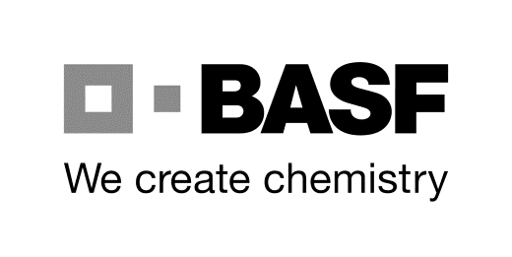
BASF SE
ESM/WWA – J 660
phone +49 621 60-46196, fax +49 621 60- 49390
e-Mail: ausweisstelle-lu@basf.com
67056 Ludwigshafen, Germany
office hours: Monday – Friday 07.00 am – 03.30 pm

Application for: BASF Group-/Cooperation ID card extension

authority ID card PLUS gateway licence extension / Nr._____________

authority ID card WITHOUT gateway licence extension

Details of BASF SE (Ludwigshafen) contact person:

Company Code | code-designation | cost centre | building | phone
 |  |  |  | +49 621 60-
last name, first name | signature of BASF contact person |  | duration of order/project
 |  |  | (max. 12 month)

Information: badge holder and companies
Date: Juni 2018
last name |  |  | first name |  |  | name of birth | identification number
date of birth DD.MM.YYYY | Nationality |  | Mr./Mrs. |  |  | title (Dr./Prof.)
activity/deployment as |  |  | PC-access required |  |  |  | occupation
NO YES
Employees who already have a PC access <NO> tick
internal phone number in Ludwigshafen (if available)
BASF Group-/Cooperation |  |  |  |  |  |  | company
street or PO box
postal code and city
administrator ESM/WWA |  | date of receipt |  | end of assignment

Declaration by ID card holder & Notes on storage of personal data & Video surveillance on page 2

BASF SE
ESM/WWA – J660
phone +49 621 60-46196, fax +49 621 60- 49390
e-Mail: ausweisstelle-lu@basf.com
67056 Ludwigshafen, Germany
office hours: Monday – Friday 07.00 am – 03.30 pm
office h

Information on submission of application:

To ensure a smooth and quick execution of the application, please attend the following notes:
- The current application can be found at the following internet address:
https://www.basf.com/de/de/company/about-us/sites/ludwigshafen/working-at-the-site/contactors-renters-partners.html
- These application must be completed in full by using a PC (not hand-written),
The completed printout must then be forwarded to the contact person at BASF (for signing).
- The BASF contact person responsible must sign the application in the relevant field (2nd line – 2nd field),
before the application is submitted to the ID card office.
The BASF contact person should make a copy of the application he or she has approved, for his or her records.
- 3 days after receipt of the correct and complete document (you will not be informed), the ID card can be collected by
the ID card holder on presentation of his or her original-identity card/passport & original-documents.
- ID card numbers for PC access will NOT by provided in advance by the ID card office.
- If the ID card is not collected after 4 weeks, applications will be regarded as canceled and cannot be subsequently reactivated.
- A change to the form will cause the application to become invalid.
- At the end of deployment, ESM/WWA must be informed of this in writing by the BASF contact person.
- After the duration, the ID card has to be returned to the ID card office.

