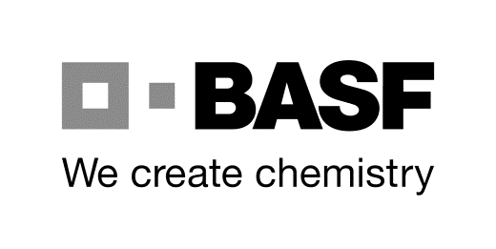
BASF SE
ESM/WWW – Gate 15
Phone +49 621 60-71454
Email: drive-ausweisstelle-tor15@basf.com
67056 Ludwigshafen, Germany
Opening hours: Monday - Friday 7:30 a.m.– 3:30 p.m

Application for: DRIVE ID (Miffo 26) Extension of a DRIVE ID

Information from the BASF contact at the Ludwigshafen site:

Company code (BASF SE or BASF IT S. etc) | Code designation | Building | Phone
 | G-FSO/EE | Y001 | +49 621 60-92540
Last name, first name | Signature of BASF contact and | Duration of the task/project (to be filled in by contact)
Christoph Respondek | As agreed, currently valid without signature | 3 years

Information on the ID owner and participating companies:
Issue: Nov. 2019
Last name |  |  | First name |  |  | Birth name |  | ID number
Date of birth MM.DD.YYYY | Nationality |  | Salutation Mr./Ms./Mrs. |  |  | Personal title (Dr./Prof.)
Forwarding company |  |  |  |  | Subcontracted forwarding company |  |  | Key number contractor
Street or PO Box |  |  |  |  | Street or PO Box
 |  |  |  |  |  |  |  | Key number subcontractor
Postal code and city |  |  |  |  | Postal code and city
Driver’s license issued for / valid until MM.DD.YYYY |  |  |  | ADR driver’s license (Carriage of Dangerous Goods by Road)
CE valid until  Driver’s cell phone number |  |  |  | ADR driver’s license no.  Valid until  ISOPA license no.  Valid until
Name / phone no. of external contact / supervisor of forwarding company
Mr./Ms./Mrs. ,
Phone
Email:
Specialist ESM/WWW |  | Application received on |  | End of limitation
Forwarding company stamp of the BASF contracting partner / Date / Signature of supervisor /
Repeat (printed letters )

Note/declaration of ID holder when picking up the ID and notes on data storage and video surveillance on Page 2

BASF SE
ESM/WWW – Gate 15
Phone +49 621 60-71454
Email: drive-ausweisstelle-tor15@basf.com
67056 Ludwigshafen, Germany
Opening hours: Monday - Friday 7:30 a.m.– 3:30 p.m

Notes on application submission:

To ensure that your application is processed quickly and without any problems, please consider the following aspects:

- The current valid application forms are available on the internet at the following address (outdated applications are no longer valid): lhttps://www.basf.com/de/de/company/about-us/sites/ludwigshafen/working-at-the-site/contactors-renters-partners.htm
These applications must be filled out entirely on a PC (not by hand)
then printed and subsequently stamped and signed by the external supervisor!
The completed printout must then be submitted to the ID office.
- Only the commissioned forwarding company is authorized to submit the application (subcontracted forwarding companies may not submit applications)!
- The ID can be picked up in person by the ID holder 3 days after receipt of the proper and completed documents (no notification). The ID holder shall present an original version of a personal identity card/passport, ADR certification and driver’s license.
- A safety test must be completed when picking up the ID card.
Information on the safety test is available on the BASF homepage:
https://www.basf.com/de/de/company/about-us/sites/ludwigshafen/working-at-the-site/contactors-renters-partners.html
- Applications are filed for 4 weeks. Once this period has expired, all data records will be deleted and cannot be reactivated.
- Any changes to the form result in the application becoming invalid!
- ESM/WWW shall be notified in writing when the commissioned work is completed.
- The ID card must be returned to us when the work is completed!

